Experiment comparing speeds of GPU execution for different command of data transfer by CUDA from CPU to GPU.
Three tensors:
- One pinned (t1)
- One paged (t2)
- One on cuda
Exepriment:
-Perform a copy operation on one tensor, and a cuda operation (multiplication), and see if they happen at the same time or not.
Note: the command here used for copying is "to()"
Some terminology:
H2D – host to device
D2H – device to host
In the context of gpu's, we call the gpu the device, while the host is the cpu.
Both terms refer to the flow of data between the two points.

In the first run, we are copying the paged tensor and running the cuda operation.
The result: while the copy operation is taking place, the cuda operation waits.
Same for pinned memory if we do not start an additional cuda stream.
Only if we pin memory AND start an additional cuda stream (for copying) do we get overlap with another cuda kernel executed on the main stream.

Pin_memory() – pytorch command that enables to cast cpu tensors to pinned memory.
This command is blocking on the host's main thread.
Result: sending a pinned memory tensor to gpu (aka casting), is much faster than a pageable tensor, as expected and explained in the introduction.
If we only have a single stream (the main one), then pin_memory() will cause a blocking operation of copying the information to memory.
Therefore, he advantage of using pin_memory is when we can start multiple threads and start the operation in parallel.
For that we have to make use of an argument, called non_blocking.
This argument, as its name implies, designates the operation it is called with to be executed asynchronously.
Note, that in terms of data integrity, when performing asynchronous operations we are more susceptible to operations on the same piece of data happening out of order. Therefore when making asynchronous calls, we need to call the synchronize() command in the end to ensure full and correct completion of the asynchronous operations, before proceeding.
For example, if we are performing a computation on data, asynchronously, we call synchronize to ensure the computation is fully finished before the function that wraps it returns.
This is also important for accurate profiling timing measurements.
When we set non_blocking = true. – ie transferring tensors from cpu to gpu asynchronously.

Goal: optimize the program for the GPU.
Model: lightweight MLP
Dataset: MNIST digits
Functions:
In mnist_main:
train_epoch(dataloader, model, loss_fn, optimizer, device)
evaluate(dataloader, model, loss_fn, device)
In mnist_inference:
Non-recurrent commands:
    - NeuralNetwork().to(device)
    - Model.eval()
Recurrent commands:
    - Tensor.to(device)
    - Output=model(X)
    - Torch.softmax(output,dim=1)
    - Torch.argmax(probabilities,dim=1).item()

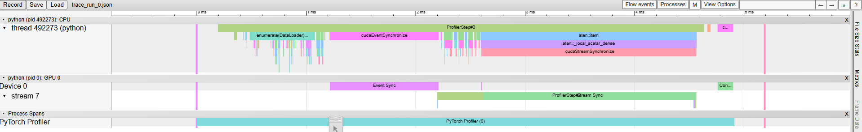
Profiling inference:
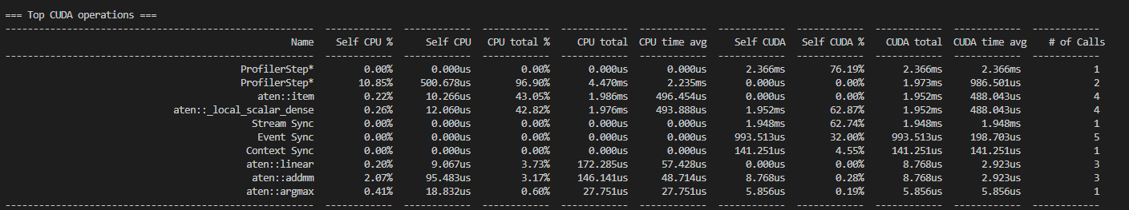
16.09.2025
First profiler run:
Code structure:
- Initialize dataset into dataloader, with pin_memory arg set to True.
- Loop through examples in dataloader
- Sending example to cuda device (with arg non_blocking set to True)
- Calling model(X)
- Calling probabilities (softmax)
- Calling predicted_class (argmax)

Results:
- Order of operations in practice:
- CPU
- Commands repeat in a cycle
- Cycle length (approx): 910 $μs$
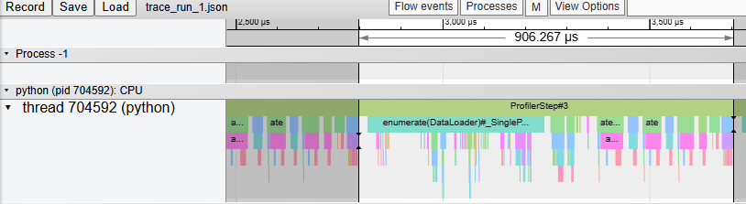
- Breakdown of the cycle:
  - First half: enumerate
    - Command type: copy
    - No GPU activity
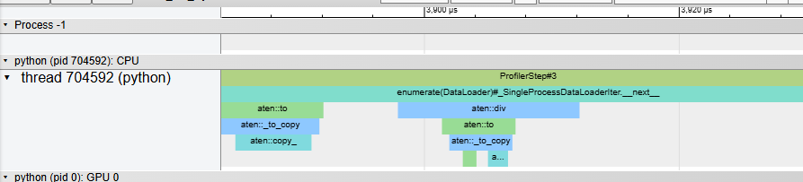
  - Second half: computations
    - Linear, relu, softmax, argmax
    - Calls to GPU – sparse and short, none parallelized.
      - Average exec time for GPU instr < 5 $μs$ , <10 calls per cycle
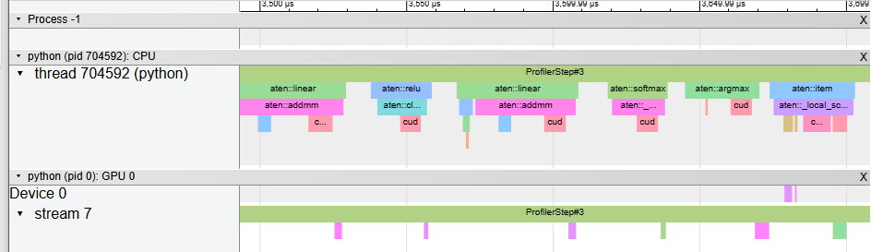

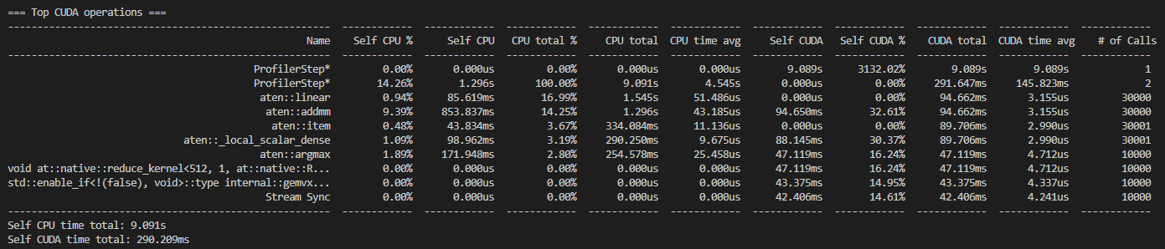
Results summary:

Longest overall CUDA operations (by time and percentage):
ProfilerStep is the reference length (runs 100% of time)
Linear (17% of cpu time)
Addm (14% of cpu time, cuda time says 32% but seems off because it runs much less time – says profiler step for cuda is 3000% which is wrong)
Local_scalar_dense (3% of cpu time)
Argmax (2.8% of cpu time, 16% of gpu time)
Note: Enumerate command (which is high percentage but parallelized does not appear in table)

Inefficiencies:
Most of the load is on the cpu.

